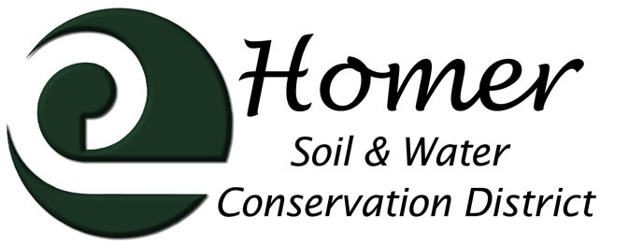
Meeting Agenda
4014 Lake St., Suite 201
Homer, AK 99603
907-235-8177 ext. 5
info@homerswcd.org

June 7th, 2017

5:00 PM

USDA Service Center, 4014 Lake St Homer, AK
- Call to order
- Roll call
- Approval of the Agenda
- Approval of the Minutes
- Visitors
  - NRCS Report
  - Other guests
- Financial Report
- Manager’s Report
  - Trails
  - Invasive Plant Program
  - Employee Update
  - Grant Update

- Old Business
  - Cooperator List
  - Rhodiola Equipment
  - Water Rights
- New Business
  - Local Working Group
  - Bison stories
  - Other?

Next Meeting July12th, 2017, 5 or 6pm???

