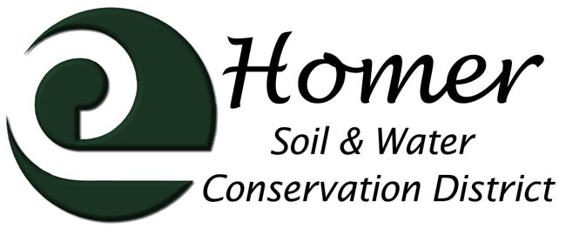
Meeting Agenda
4014 Lake St., Suite 201
Homer, AK 99603
907-235-8177 ext. 5
info@homerswcd.org

May 10th, 2017

5:00 PM

USDA Service Center, 4014 Lake St Homer, AK
- Call to order
- Roll call
- Approval of the Agenda
- Approval of the Minutes
- Visitors
  - KPB Land leases and programs: Marcus Mueller
  - NRCS Report : Karin Sonnen and Jared Worthington (7pm)
  - Other guests
- Financial Report
- Manager’s Report
  - Trails
  - Invasive Plant Program
  - Grant Update
  - Employee Update
- Old Business
  - Employee Pay Rates
  - Cooperator List
  - Rhodiola Equipment
  - Water Rights

Next Meeting June 14th, 2017

